

***INSTITUTE OF INFORMATION TECHNOLOGY***

***JAHANGIRNAGAR UNIVERSITY***

**Lab Final**

**Submission Date :** 15/07/2021

**Course Tittle :** Object Oriented Programming Lab

**Course Code :** ICT - 1204

**Submitted To Submitted By**

Dr. Jesmin Akhter Md. Shakil Hossain

Professor Class Roll – 2023

IIT – JU Exam Roll – 192340

IIT – JU

**Answer to the question no 6**

#include<iostream>

using namespace std;

class employee

{

string name, designation;

int age, salary;

public:

void getData()

{

cout<<"Detail of a employee:";

cout<<"\n-------------------------\n";

cout<<"Name: "<<name;

cout<<"\nAge: "<<age;

cout<<"\nDesignation: "<<designation;

cout<<"\nSalary: "<<salary;

cout<<"\n\n";

}

void putData()

{

cout<<"Enter detail of Employee:";

cout<<"\n-------------------------\n";

cout<<"Name: ";

string nw;

getline(cin,nw);

name=nw;

cout<<"Age: ";

cin>>age;

cout<<"Designation: ";

cin>>designation;

cout<<"Salary: ";

cin>>salary;

cout<<"\n";

cin.ignore();

}

};

int main()

{

cout<<"Number of employee to insert:";

int n;

cin>>n;

employee arr[n];

cin.ignore();

for(int i=0; i<n; i++)

{

employee nw;

nw.putData();

arr[i]=nw;

}

for(int i=0; i<n; i++)

{

arr[i].getData();

}

}

**Output**

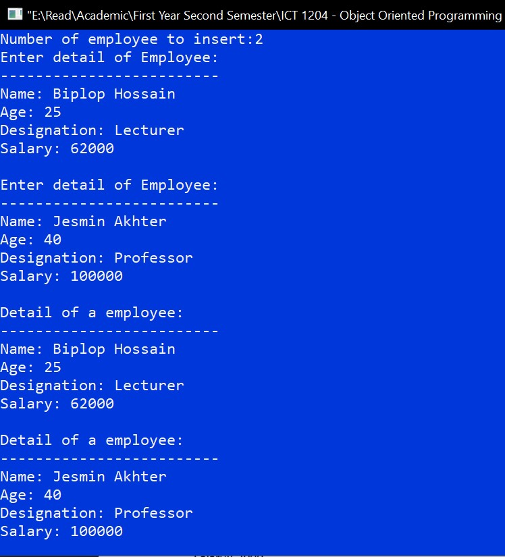

**Answer to the question no 11**

**My Menu**

package finallab;

public class MyMenu extends javax.swing.JFrame {

public MyMenu() {

initComponents();

}

@SuppressWarnings("unchecked")

// <editor-fold defaultstate="collapsed" desc="Generated Code">

private void initComponents() {

jMenuBar1 = new javax.swing.JMenuBar();

jMenu1 = new javax.swing.JMenu();

jMenuItem1 = new javax.swing.JMenuItem();

jMenuItem2 = new javax.swing.JMenuItem();

jMenu2 = new javax.swing.JMenu();

jMenu3 = new javax.swing.JMenu();

setDefaultCloseOperation(javax.swing.WindowConstants.EXIT_ON_CLOSE);

jMenu1.setText("File");

jMenuItem1.setText("login");

jMenuItem1.addActionListener(new java.awt.event.ActionListener() {

public void actionPerformed(java.awt.event.ActionEvent evt) {

jMenuItem1ActionPerformed(evt);

}

});

jMenu1.add(jMenuItem1);

jMenuItem2.setText("Exit");

jMenu1.add(jMenuItem2);

jMenuBar1.add(jMenu1);

jMenu2.setText("Edit");

jMenuBar1.add(jMenu2);

jMenu3.setText("Help");

jMenuBar1.add(jMenu3);

setJMenuBar(jMenuBar1);

javax.swing.GroupLayout layout = new javax.swing.GroupLayout(getContentPane());

getContentPane().setLayout(layout);

layout.setHorizontalGroup(

layout.createParallelGroup(javax.swing.GroupLayout.Alignment.LEADING)

.addGap(0, 400, Short.MAX_VALUE)

);

layout.setVerticalGroup(

layout.createParallelGroup(javax.swing.GroupLayout.Alignment.LEADING)

.addGap(0, 269, Short.MAX_VALUE)

);

pack();

}// </editor-fold>

private void jMenuItem1ActionPerformed(java.awt.event.ActionEvent evt) {

new Login1().setVisible(true);

}

public static void main(String args[]) {

/* Set the Nimbus look and feel */

//<editor-fold defaultstate="collapsed" desc=" Look and feel setting code (optional) ">

/* If Nimbus (introduced in Java SE 6) is not available, stay with the default look and feel.

* For details see http://download.oracle.com/javase/tutorial/uiswing/lookandfeel/plaf.html

*/

try {

for (javax.swing.UIManager.LookAndFeelInfo info : javax.swing.UIManager.getInstalledLookAndFeels()) {

if ("Nimbus".equals(info.getName())) {

javax.swing.UIManager.setLookAndFeel(info.getClassName());

break;

}

}

} catch (ClassNotFoundException ex) {

java.util.logging.Logger.getLogger(MyMenu.class.getName()).log(java.util.logging.Level.SEVERE, null, ex);

} catch (InstantiationException ex) {

java.util.logging.Logger.getLogger(MyMenu.class.getName()).log(java.util.logging.Level.SEVERE, null, ex);

} catch (IllegalAccessException ex) {

java.util.logging.Logger.getLogger(MyMenu.class.getName()).log(java.util.logging.Level.SEVERE, null, ex);

} catch (javax.swing.UnsupportedLookAndFeelException ex) {

java.util.logging.Logger.getLogger(MyMenu.class.getName()).log(java.util.logging.Level.SEVERE, null, ex);

}

//</editor-fold>

/* Create and display the form */

java.awt.EventQueue.invokeLater(new Runnable() {

public void run() {

new MyMenu().setVisible(true);

}

});

}

// Variables declaration - do not modify

private javax.swing.JMenu jMenu1;

private javax.swing.JMenu jMenu2;

private javax.swing.JMenu jMenu3;

private javax.swing.JMenuBar jMenuBar1;

private javax.swing.JMenuItem jMenuItem1;

private javax.swing.JMenuItem jMenuItem2;

// End of variables declaration

}

**Output**

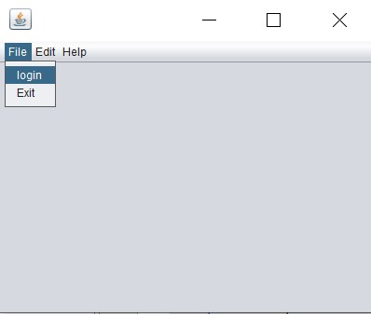

**Login**

package finallab;

import javax.swing.JOptionPane;

public class Login1 extends javax.swing.JFrame {

public Login1() {

initComponents();

}

@SuppressWarnings("unchecked")

// <editor-fold defaultstate="collapsed" desc="Generated Code">

private void initComponents() {

display = new javax.swing.JTextField();

jLabel1 = new javax.swing.JLabel();

jLabel2 = new javax.swing.JLabel();

txtid = new javax.swing.JTextField();

passwrd = new javax.swing.JPasswordField();

login = new javax.swing.JButton();

exit = new javax.swing.JButton();

jLabel3 = new javax.swing.JLabel();

setDefaultCloseOperation(javax.swing.WindowConstants.EXIT_ON_CLOSE);

jLabel1.setText("ID");

jLabel2.setText("Password");

txtid.addActionListener(new java.awt.event.ActionListener() {

public void actionPerformed(java.awt.event.ActionEvent evt) {

txtidActionPerformed(evt);

}

});

passwrd.addActionListener(new java.awt.event.ActionListener() {

public void actionPerformed(java.awt.event.ActionEvent evt) {

passwrdActionPerformed(evt);

}

});

login.setText("Login");

login.addActionListener(new java.awt.event.ActionListener() {

public void actionPerformed(java.awt.event.ActionEvent evt) {

loginActionPerformed(evt);

}

});

exit.setText("Exit");

exit.addActionListener(new java.awt.event.ActionListener() {

public void actionPerformed(java.awt.event.ActionEvent evt) {

exitActionPerformed(evt);

}

});

jLabel3.setIcon(new javax.swing.ImageIcon(getClass().getResource("/finallab/1.jpg"))); // NOI18N

jLabel3.setText("jLabel3");

javax.swing.GroupLayout layout = new javax.swing.GroupLayout(getContentPane());

getContentPane().setLayout(layout);

layout.setHorizontalGroup(

layout.createParallelGroup(javax.swing.GroupLayout.Alignment.LEADING)

.addGroup(layout.createSequentialGroup()

.addGap(62, 62, 62)

.addGroup(layout.createParallelGroup(javax.swing.GroupLayout.Alignment.TRAILING)

.addGroup(layout.createParallelGroup(javax.swing.GroupLayout.Alignment.LEADING, false)

.addGroup(javax.swing.GroupLayout.Alignment.TRAILING, layout.createSequentialGroup()

.addComponent(login)

.addGap(33, 33, 33)

.addComponent(exit))

.addGroup(layout.createSequentialGroup()

.addGroup(layout.createParallelGroup(javax.swing.GroupLayout.Alignment.LEADING)

.addComponent(jLabel1, javax.swing.GroupLayout.PREFERRED_SIZE, 50, javax.swing.GroupLayout.PREFERRED_SIZE)

.addComponent(jLabel2, javax.swing.GroupLayout.PREFERRED_SIZE, 59, javax.swing.GroupLayout.PREFERRED_SIZE))

.addGap(40, 40, 40)

.addGroup(layout.createParallelGroup(javax.swing.GroupLayout.Alignment.LEADING, false)

.addComponent(txtid)

.addComponent(passwrd, javax.swing.GroupLayout.PREFERRED_SIZE, 127, javax.swing.GroupLayout.PREFERRED_SIZE))))

.addComponent(jLabel3, javax.swing.GroupLayout.PREFERRED_SIZE, 197, javax.swing.GroupLayout.PREFERRED_SIZE))

.addContainerGap(145, Short.MAX_VALUE))

);

layout.setVerticalGroup(

layout.createParallelGroup(javax.swing.GroupLayout.Alignment.LEADING)

.addGroup(layout.createSequentialGroup()

.addContainerGap()

.addComponent(jLabel3)

.addGap(33, 33, 33)

.addGroup(layout.createParallelGroup(javax.swing.GroupLayout.Alignment.BASELINE)

.addComponent(jLabel1, javax.swing.GroupLayout.PREFERRED_SIZE, 24, javax.swing.GroupLayout.PREFERRED_SIZE)

.addComponent(txtid, javax.swing.GroupLayout.PREFERRED_SIZE, javax.swing.GroupLayout.DEFAULT_SIZE, javax.swing.GroupLayout.PREFERRED_SIZE))

.addGap(18, 18, 18)

.addGroup(layout.createParallelGroup(javax.swing.GroupLayout.Alignment.BASELINE)

.addComponent(jLabel2, javax.swing.GroupLayout.PREFERRED_SIZE, 23, javax.swing.GroupLayout.PREFERRED_SIZE)

.addComponent(passwrd, javax.swing.GroupLayout.PREFERRED_SIZE, javax.swing.GroupLayout.DEFAULT_SIZE, javax.swing.GroupLayout.PREFERRED_SIZE))

.addGap(34, 34, 34)

.addGroup(layout.createParallelGroup(javax.swing.GroupLayout.Alignment.BASELINE)

.addComponent(login)

.addComponent(exit))

.addContainerGap(62, Short.MAX_VALUE))

);

pack();

}// </editor-fold>

private void txtidActionPerformed(java.awt.event.ActionEvent evt) {

}

private void loginActionPerformed(java.awt.event.ActionEvent evt) {

String id, pas;

id = txtid.getText();

pas = passwrd.getText();

if (id.equals("Shakil") && pas.equals("12345")) {

JOptionPane.showMessageDialog(null, "Successfully");

Login1 connect = new Login1();

connect.setVisible(true);

} else {

JOptionPane.showMessageDialog(null, "Login Unsuccessfully");

}

}

private void exitActionPerformed(java.awt.event.ActionEvent evt) {

System.exit(0);

}

private void passwrdActionPerformed(java.awt.event.ActionEvent evt) {

}

public static void main(String args[]) {

/* Set the Nimbus look and feel */

//<editor-fold defaultstate="collapsed" desc=" Look and feel setting code (optional) ">

/* If Nimbus (introduced in Java SE 6) is not available, stay with the default look and feel.

* For details see http://download.oracle.com/javase/tutorial/uiswing/lookandfeel/plaf.html

*/

try {

for (javax.swing.UIManager.LookAndFeelInfo info : javax.swing.UIManager.getInstalledLookAndFeels()) {

if ("Nimbus".equals(info.getName())) {

javax.swing.UIManager.setLookAndFeel(info.getClassName());

break;

}

}

} catch (ClassNotFoundException ex) {

java.util.logging.Logger.getLogger(Login.class.getName()).log(java.util.logging.Level.SEVERE, null, ex);

} catch (InstantiationException ex) {

java.util.logging.Logger.getLogger(Login.class.getName()).log(java.util.logging.Level.SEVERE, null, ex);

} catch (IllegalAccessException ex) {

java.util.logging.Logger.getLogger(Login.class.getName()).log(java.util.logging.Level.SEVERE, null, ex);

} catch (javax.swing.UnsupportedLookAndFeelException ex) {

java.util.logging.Logger.getLogger(Login.class.getName()).log(java.util.logging.Level.SEVERE, null, ex);

}

//</editor-fold>

/* Create and display the form */

java.awt.EventQueue.invokeLater(new Runnable() {

public void run() {

new Login1().setVisible(true);

}

});

}

// Variables declaration - do not modify

private javax.swing.JTextField display;

private javax.swing.JButton exit;

private javax.swing.JLabel jLabel1;

private javax.swing.JLabel jLabel2;

private javax.swing.JLabel jLabel3;

private javax.swing.JButton login;

private javax.swing.JPasswordField passwrd;

private javax.swing.JTextField txtid;

// End of variables declaration

}

**Output**

